Paul Catherall

Postgraduate Diploma/ MA Information and Library Management.

Module:
Managing Data.

Module Leader:
Janet Farrow

Title of Assignment:
Question 1, (Second Generation DOS/UNIX-based library management system.)

Final Submission Date:
11/05/’00

Proposal for New Library Management System.

Question 1,

The replacement of a 2nd Generation Library Management System.

(Llanelwy University, North Wales.)

(i) Overview to Proposal.

This proposal considers the advantages of replacing our existing Library Management System at Llanelwy University with a more recent and powerful system.
The proposal is presented in three main sections:

1. An assessment of developments in Library Management System features and
capabilities since our present system was installed in 1988.

2. An overview of selected system suppliers, and evaluation of their products.

3. An evaluation of management issues which may require consideration should a
new system be implemented.

(ii.) Methodology.

Where possible, a wide variety of sources have been consulted in compiling this proposal, including online supplier documentation, recently published articles and books, and statistical reference works.

(iii.) A Glossary of Terms.

Occasionally, it is preferable to use the abbreviated form for some technical terms and jargon. These are a few frequently used throughout this proposal:

SQL - Structured Query language; the standard formatting script used in some
database systems. SQL allows integration and interchange between
databases of different format, architecture and function.

RDBMS - Relational Database Management System; these databases are designed
for interoperability between various different applications or statistical
utilities. They often use SQL or Oracle standard formatting,
allowing both for system-level and cross-format data interchange.

OSI - Open Systems Interconnection; term often referred to in describing
standardisation of communications protocols and systems for data transfer.
The client-server model, running on TCP/IP protocols is an example of
open systems architecture used by many library management systems.

Z39.50 - Applications Layer protocol used to transfer data between database
systems on the internet. The standardisation of Z39.50 has provided an
easier means of communication between RDBMS and library management
systems than existed previously under UNIX and similar integrated
network systems.

SR - Search & Retrieve; another standard Applications Layer protocol used to
transfer data between database systems on the Internet.

EDI - Electronic Data Interchange; system allowing manual and automated
transfer of electronic documents between suppliers and buyers. This
system requires the supplier subscribe to a First edition or TeleOrdering
EDI network.

EDS - Executive Data System; advanced auditing and statistical report functions
present in some third and fourth generation library management systems.

GUI - Graphical User Interface; increasingly popular interactive graphical
display format supported by many operating systems and software.
GUI is usually characterised by the WIMP standard, (Windows, Icons,
Menus, and Pointers.)

CLI - Command Language Interface; text-based interface accompanied by formal
command language. CLI is largely necessary to communicate with the
computer at the lower machine-code level. CLI-based applications are
usually more efficient than GUI counterparts because of their greater
proximity to machine code, and because they do not generally require
graphics processing.

(iv.) The Present Library Management System.

The present system in use by Llanelwy University library is the formerly popular PENOPAC system, developed by Penddraig Network Solutions and installed on our Local Area Network in 1988.
The PENOPAC system is a fully integrated second generation library management system, requiring a UNIX-based server. PENOPAC is also a CLI-based system, using a comprehensive text-layout and static options menu.

Despite its text-only interface, PENOPAC is still popular amongst staff and students, for its accessible control-key menu interface and well labelled menu options.
PENOPAC was provided as a ‘turnkey’ system, this meant that the PENOPAC system software was able to run on our own UNIX-based server machine, but we required several specially designed PENOPAC terminals to access the system.
The PENOPAC terminals are ‘dumb’ client computers, and perform no processing functions whatsoever; they simply allow for interaction with local server
resources using a text-only interface, and are solely for use with the PENOPAC system.
There are two separate PENOPAC applications comprising the system, both accessed using the PENOPAC terminals:

- The online management access catalogue (OMAC.)
- The online public access catalogue (OPAC.)

There are several terminals around the library for public access to the OPAC,
allowing users to place holds, renew items and view the status of their account.
In addition, users may search the catalogue for items located within the University libraries. The interface is mainly menu-driven, allowing users to choose a variety of options at the initial screen, including language choice, catalogue search, view personal record, read the library online bulletin board or disconnect (deactivated at present.)

Figure 1. PENOPAC initial menu.

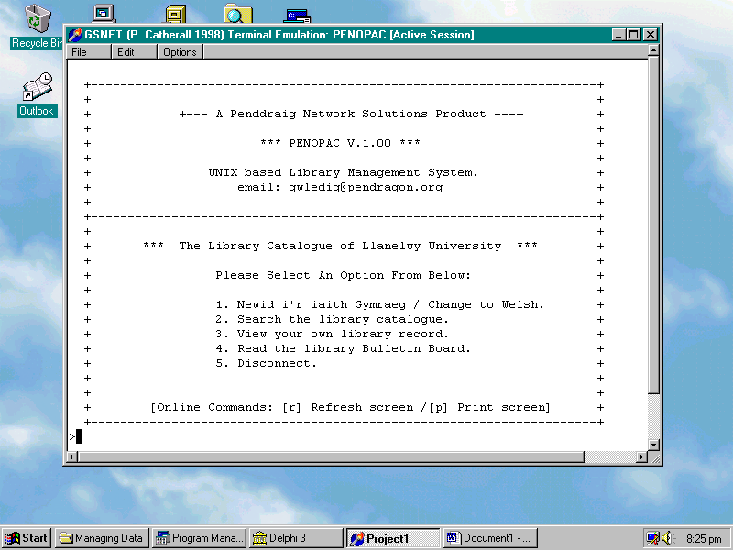

The search menu contains a number of searching features, including search by author, title, keywords and Dewey number.

Figure 2. The OPAC Search Options Menu.

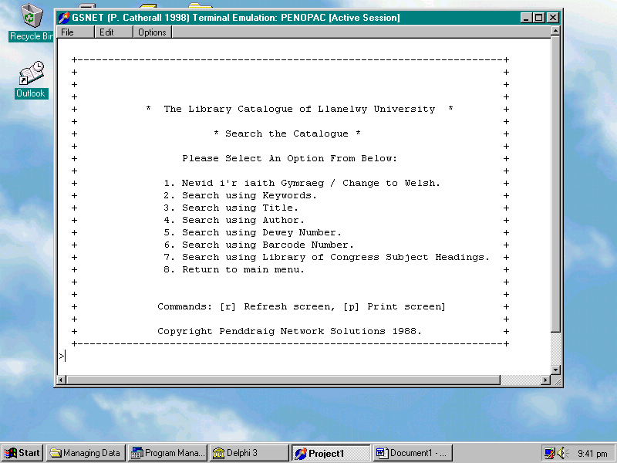

Terminals are also used at the issues desk for access to the online management component of PENOPAC. A variety of circulation and account-maintenance functions are carried out at the issues desk, including issues, returns, renewals, financial transactions and account updates. In addition, management access terminals are present in our main offices for library acquisitions and cataloguing functions. PENOPAC stores library item records in its own proprietary format, and item and user files are stored and updated on separate files.

Figure 3. Patron Record Maintenance.
The patron record screen allows a variety of functions for staff manipulation of patron accounts, allowing modification of fines, due-dates and user-status.
Patron contact and departmental information, issued items, due dates and fines are all shown:

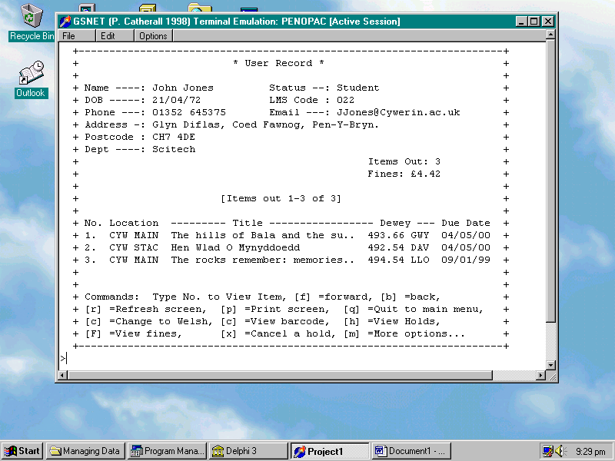

In addition to local terminal access, the OPAC is also available via conventional terminal emulation software across the internet, (eg: using Windows telnet,) and is therefore available at all the university sites across the city via networked PCs, and for remote access via the internet.

(v.) Developments in LMS technology.

The third and fourth generation Library management systems of the 1990s are characterised by five main aspects largely absent in our present system:

- Relational Database Management Systems (RDBMS),
- GUI interface capabilities,
- Expandable Multi-Tier Software Design.
- International data format standards,
- International Communications standards,
- Online resource accessibility, sharing and acquisitions.

- Relational Database Systems.

The use of Oracle and SQL standards in database design have allowed systems to use a non-proprietary database architecture, thereby enabling both data compatibility within the same system and between different systems.
In real terms, this means that library systems with RDBMS can share and manipulate data across a wide variety of application formats for a variety of purposes.
Examples of RDBMS on a local level might include a central student records database used both for academic reference and library management.
RDBMS therefore facilitates enhanced task and project management by providing, maintaining and updating common data for a variety of purposes.
Additionally, RDBMS also provides a high level application standard for internet resource retrieval and resource sharing, particularly relevant when considering the central provision and maintenance of online item records databases by companies such as ExLibris.
In addition, RDBM also allows for local SQL compliant application support, enabling information managers to process statistical and other system data using familiar industry-standard applications, such as Excel and Access.
It should be noted that our proprietary DBMS is incompatible with any industry-standard model, and that we rely solely on the limited report module provided with the system 12 years ago.

- Expandable Multi-Tier Software Design.

Because the new systems are built using relational database systems, each module
functions independently of interpretable data. Additionally, recent system modules are not interdependent, but act individually and are interoperational with the system as a whole. This multi-tiered approach means that systems can be upgraded much more easily than in the past. Additionally, newer systems are built using more modern and more reliable object-oriented programming languages, often developed using sophisticated web design scripts or external languages, such as Java and Visual Basic. These recent programming languages are often themselves based on modular systems, so that applications are more easily debugged and upgraded than applications written in older, more complex CLI-developed languages.

- GUI interface capabilities.

The emergence of GUI peripheral operating systems, such as Windows, have led to the growth in user-demand for more user-friendly and intuitive user interfaces.
Many recent library management systems, such as Heritage and Voyager, provide a variety of traditional and innovative library interface functions via the WIMP standard, using buttons, icons, pull-down menus and data-entry fields. In addition, GUI systems are now mouse, rather than keyboard-driven, and rely much less on CLI command libraries, such as those essential to our PENOPAC system.

- International data format standards.

Unlike our proprietary item record format, more recent systems allow for
the flexible importing, maintenance and export of item records and other data classes.
Recent systems support a variety of bibliographic standards, including MARC, USMARC, UKMARC, UNIMARC, MAB, AACR2 and others.
In addition to allowing flexible import and manipulation of data formats, some systems also allow format conversions and customisable format entry.
In the new Endeavour system, the user may select the data format to compile records, or design a new customisable record format.
In Heritage IV, a proprietary field-entry record format is used, but a variety of import formats are possible.
In addition to traditional bibliographic and authority files, some systems also support more recent record formats, including XML (Extensible mark-up language,) which allows for advanced relational and hierarchical data scripts.
Because of the flexible approach to format types, newer systems also provide easier system migration functions. One of the drawbacks of proprietary systems is incompatibility with new systems formats. At Llanelwy University, we have solved this problem with PENOPAC, since Penddraig, its producer, has developed a MARC conversion module which we have acquired.

- International Communications standards.

There are several major hardware, communications and data exchange standards presently in place, which our older, largely proprietary system cannot take advantage of.
Client-server network architecture is now a feature of all recent library management systems, incorporating standard communications protocols, such as TCP/IP (Transfer control protocol/ internet protocol,) and standard Web/ applications layer protocols, such as HTTP (hypertext transfer protocol,) and CGI (Common gateway interface protocol and script.)
Additionally, the inclusion of the Z39.50 applications layer protocol in many DBMS systems has enabled a standard data transfer method via different applications formats.
One real benefit of Z39.50 is the accessibility/sharing of data between item-record databases across the world via the internet, using both browser-based and windows-based systems.

- Online resource accessibility, sharing and acquisitions.

Using Z39.50 and other communications standards, many library management system producers now provide links to a large number of OPACS and other shared resources (such as multimedia, pictures and full electronic text files,) via the internet.
Additionally, systems now offer greater functionality in book, serial and other media acquisitions, often integrating diverse acquisitions functions, such as book, serial and automated acquisitions within a single module or interface.
This is mainly achieved through the EDI (electronic data Interchange) system, which provides access to supplier networks such as First Edition.
The EDI system also allows for automated letter, receipt and invoice compilation/transmission, and for automated budget management. In some cases, EDI also provides an integrated acquisitions and fund allocation/ tracking system.
Our current system does have an acquisitions module, but is only configurable for links with a limited number of suppliers. Furthermore, there are no budgeting features with our present acquisitions module.

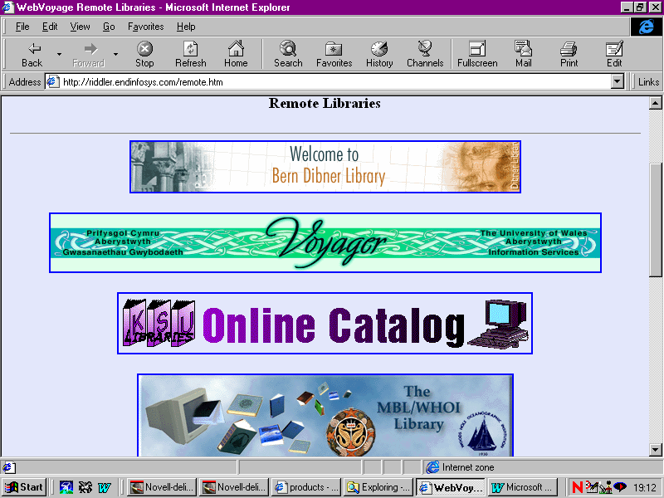
Figure 4. The Voyager Web OPAC.

(vi.) Other features of recent Library management systems.

- Improved Catalogue Generation - Many systems now allow fast catalogue creation via large item record databases. In Heritage IV, the QuickCat CD, containing over a million British library records is available for quick record integration, using the ISBN as an item retrieval key. Both the Aleph and Talis systems feature similar extensive online item record support.

- Improved Authority Controls - Recent systems feature extensive authority controls, for qualifiers such as titles, author, Library of Congress subject headings and access points. Some systems also provide an integrated thesaurus with this system.

- Self-Circulation Systems - Some systems offer self-issue and self-return functionality, alongside traditional renewal and holdings features. Some newer systems have integrated products for self-service, or collaborate with another major producer, such as 3M.

- Interlibrary Loans and other item requests - Some systems have ILL modules, allowing the user to request an ILL via the OPAC; customisable user-entry forms are provided on some systems.
In some cases, systems also have article/ document request modules,
and these are sometimes integrated with the ILL system.

- Systems Management - Some newer systems have an integrated management system, providing statistical feedback and automated reports according to modules within the system, or defined parameters. More advanced systems also have in-built graphical report functions, and report-writing facilities to create a customised report using user-defined parameters. With the development of RDBMS technology, many recent systems now allow access to statistical information via familiar SQL compliant database applications, such as Excel.

- Enhanced OPAC features - these include features not supported by PENOPAC, such as natural language searching, rather than controlled, or Boolean searching, a GUI interface, wild-card truncation and enhanced metadata-based indexing and search techniques. In addition, some systems now offer customisable interfaces for the user, or the choice of either a GUI or CLI based interface.

- Community information - Some systems now allow for useful contacts and bulletin-information provided via a main menu or web page. These contacts might include useful community or emergency services, local events, user training sessions or other university-related activities. University announcements and bulletins are also supported via bulletin board systems.

- Security Features - these include traditional encrypting and password-protection systems, but more recent systems have incorporated intranet and web-security features in their products, such as firewall server software to filter web-server access.

(vii.) Key System Suppliers and their products.

(1.) Epixtech Inc. (Formerly Ameritech.)

A Division of ALS (American library Systems,) Ameritech was founded in 1989. In 1999, 7,600 libraries were using Ameritech systems.
Despite the fact that Ameritech is based in Utah, USA, 70% of its market is non-USA based, and it has a branch in the UK. (Epixtech WWW Pages. 2000.)
The most popular Epixtech system at the moment is the new Horizon system, supporting standard client-server architecture, acquisitions, cataloguing and circulation modules and support for both a Web and windows-based Public Access Catalogue. Horizon runs on any NT based server, and is numerically scaleable to the user-size of the organisation.

Horizon possesses the following special features:

- Multi-tier architecture, written using visual C++ for enhanced stability and expansibility.
- Multi-media DBMS to provide access to a variety of non-text resources, including pictures, midi music and other item types.
- Supports a fully-customisable GUI interface, both for administrative and OPAC modules.
- SQL-based RDBMS, for data compatibility and cross-application support.
- Homebound module, dealing with item delivery and retrieval calendars.
- Self-service module, for issues, returns, renewals and standard account status viewing.
- Advanced booking module to request items.
- Integrated email support to notify users of announcements, fines etc.
- Integrated Telecirc II functionality, to provide traditional email contact information via automated phone messages.
- Special MARC display and editing module, with customisable data-entry layout.
- Batch processing/ maintenance of item/ client records.
- Enhanced EDS management system with graphical report-writer application and access to data via SQL-compatible software.
- Supports MARC, UNIMARC, UKMARC & USMARC data formats.
- Epixtech supports regular UK Horizon workshops, user-groups and support lines.

(2.) Endeavour Information Systems Inc.

Endeavour was founded in 1994, and is based in Illinois, USA.
In 1998, the company reported profits of $17 million, with 169 sales to libraries around the world in that year. (Endeavour WWW Pages. 2000)
The most recent system produced by Endeavour is the Voyager system, which runs on a avriety of platforms, including UNIX and NT.
One of the most interesting features of Voyager is its inclusion of cutting edge XML formatting technology in its interface architecture.

Figure 5. The Voyager Web Interface Main Menu (Web Voyage Module.)

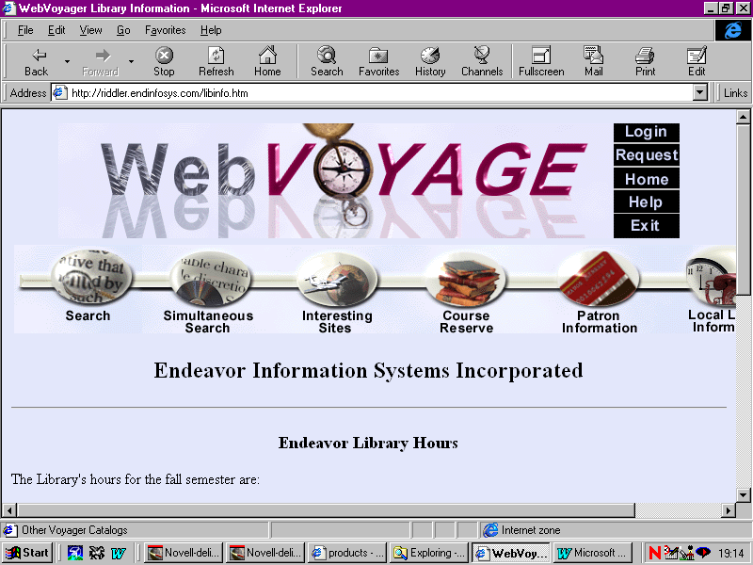

Voyager possesses the following special features:

- Use of the Oracle SQL-compliant RDBMS for data compatibility and cross-application support.
- Fully customisable OPAC and administrative modules.
- Multi-media DBMS to provide access to a variety of non-text resources, including pictures, midi music and other item types.
- Multi-tier architecture, written using visual C++ and Visual Basic for enhanced stability and expansibility.
- OPAC User-features include context-sensitive help, search file storage and customisable views.
- Integrated email support to notify users of announcements, fines etc.
- Web or Windows-based public access catalogue.
- Supports a large number of standard and innovative base operating systems and server platforms, including NT, UNIX and LINUX.
- Allows for both online browser-interface or traditional Unix CLI interface, for both OPAC and administrative modules.

(3.) ExLibris USA Inc.

ExLibris was founded in Israel in 1986. The American division has a large European market-base, and focuses mainly on the academic market and research libraries.
The company’s newest product is Aleph 500, running on a variety of platforms, including UNIX and NT, and uses the Oracle industry-standard RDBMS.
In 1998, ExLibris sold 100 systems worldwide, and has a total of 500 library clients, although there is no UK support site. On Aleph 500, I.R. Murrey has commented in the Library Journal:

‘...a state of the art client server system, with an architecture which will allow it to take on new developments in IT. Internationally, it has a wide customer based including some very large and prestigious national libraries and major companies.’

(Murrey. 1998.)

Aleph 500 possesses the following special features:

- Web and Windows-based GUI public access catalogue.
- Multi-tier architecture, written using visual C++ for enhanced stability and expansibility.
- Fully customisable OPAC and administrative modules.
- Online support of 100,000,000 records containing a variety of format types, including MARC, UKMARC and UNIMARC.
- Uses a single RDBMS to index all item records for efficient searching.
- Customisable cataloguing functions, including option of free-form or tag-based data input.
- Large authority control and thesaurus, with auto-update on new entries.
- Detailed transactions-tracking and auditing.
- Accessible by wide range of applications via RDBMS.
- Detailed management report functions, with parameter-customisable report application.
- EDI system for acquisitions and automated transactions delivery.
- ILL and article request system.
- Wide range of languages support with large character sets and multi-directional text support.
- Allows links to local databases and other online resources via hyperlinks.
- Supports Z39.50 for access to databases on the internet.
- Foreign currency support and automatic conversion functions.

(4.) Geac Computers Ltd.

Geac is a Canadian company, founded in 1973, and based in Ontario.
Despite its wide-ranging client-audience, Geac has a major site in the UK, and has been a leading provider of turnkey systems in the UK for many years.
In 1998, Geac sold 104 systems. (Geac WWW pages. 2000.)
The major new product to emerge from Geac is the latest Advance system, requiring a UNIX server platform, it provides a CLI-based administrative interface, and has a CLI-based OPAC, supported by the GeoPAC windows interface and the WebPac browser-interface OPAC modules. Of Advance, Debby Raven has commented in the LA Record:

‘...key issues focused around the need for a third generation system, based on multi-tier architecture, an integrated graphical display and the use of industry standards like an Oracle database...’
( Raven. 2000.)

Advance possesses the following special features:

- Efficient UNIX functionality provides fast data transfer and information processing.
- Web or windows-based OPAC functionality.
- Enhanced library management system and customisable reports writer system.
- Full support of MARC and BISAC.
- OPAC features cross indexed support using Boolean operators.
- Customisable macros and function keys.
- Email and bulletin systems for community information.
- Telecirc II support for telephone user notifications.
- Z39.50 database access support.
- Oracle RDBMS for cross application support.

(5.) I.S. Oxford Ltd. (Formerly Inheritance Systems.)

I.S. Oxford was founded as Logical Choice in 1982, developing the popular Bookshelf product. The company has developed Bookshelf in the form of the Heritage system, now in version 4; in 1999, 635 organisations were using Heritage IV. (I.S. Oxford WWW pages. 2000.)
Heritage IV runs on an NT server only.

Figure 6. The Heritage IV Web Interface.

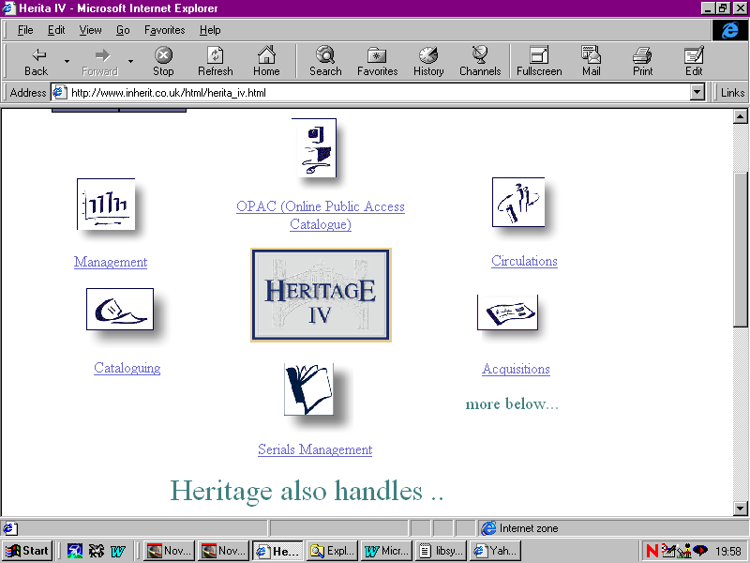

Heritage possesses the following special features:

- EDI Acquisitions module for automatic ordering and budgeting.
- Detailed budget system, including reviews of allocated funds, spent funds and yearly balance totals.
- Detailed transactions tracking system.
- Detailed report facility with customisable parameter reports.
- Access to BNB data for integration with the catalogue.
- Self-issue functions.
- Special functions allow on-screen user feedback questionnaires.
- QickCat module allows efficient retrospective cataloguing using BNB imports to compile records.
- Supported user group and email problem-report service.
- Full GUI interface for OPACS and administrative modules.

(6.) Innovative Interfaces Inc.

Innovative was founded in 1978, developing its first integrated module system in 1980. A leader in turnkey and early UNIX-based systems, Innovative has produced the first entirely web-based system, using a combination of HTML, Java and visual C++ to create the new Millennium system.
The Millennium system uses an Oracle RDBMS, and runs on any client-server architecture with web-access support, including LINUX, UNIX, MAC-server or NT platforms.
On the Millennium system, I.R. Murrey has commented in the Library Journal:

‘...The java-based client software of Millennium is one of the most impressive technological developments in integrated library systems....’

(Murrey. 1998.)

Millennium possesses the following special features:

- Multi-tiered architecture, with RDBMS-based catalogue.
- May run on any Java 2 compliant Web-server and browser.
- Written mainly in Visual C++ and Java, allowing highly flexible modifications within present system using Java upgrades.
- Fully-web dependent technology allows seamless module transparency.
- Support for 20 languages, with large character support and multidirectional text support.
- Multi-media DBMS to provide access to a variety of non-text resources, including pictures, midi music and other item types.
- Supports a fully-customisable GUI interface, both for administrative and OPAC modules.
- Oracle-based RDBMS, for data compatibility and cross-application support.
- Supports MARC, UNIMARC, UKMARC & USMARC data formats.
- Enhanced EDS system management system with graphical report-writer application and access to data via industry-standard software.

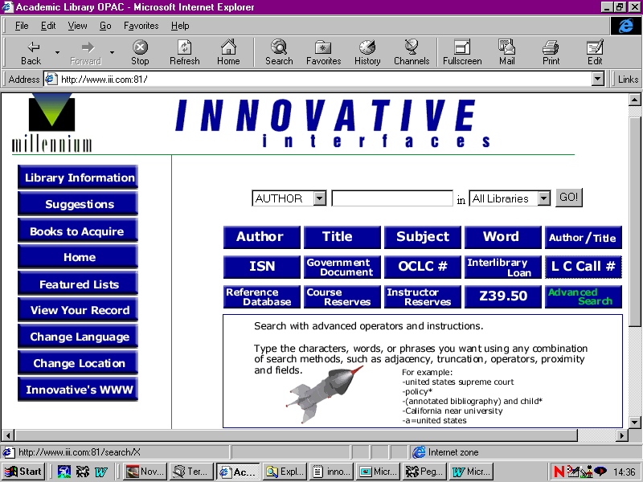
Figure 7. The Millennium Web OPAC Searching Interface.

(7.) Talis Information Ltd.

Talis was established in 1989, developed from the former Birmingham libraries cooperative mechanisation project. In 1998, Talis had 100 customers across the public library, health and university sectors.
The Talis system runs on a UNIX server, and provides Z39.50 support.
In particular, Talis is well known for working with organisations to produce custom library management solutions, and extension modules for its system.

Additionally, Talis works with companies such as 3M in providing integrated self-issue and other innovative services for system users.
Talis possesses the following special features:

- EDI acquisitions support,
- Access to 17 million Talis bibliographic records online, supporting many formats, including MARC.
- Quick cataloguing using online services for item record integration.
- Z39.50 support for internet database access.
- Also provides access to many major databases, including HMSO and BNB.
- EDS management system with SQL links to industry-standard applications support.
- Online consultancy and support unit.
- Fully customisable GUI OPAC and administration modules, using Windows NT or Web interfaces.
- user-customisable OPAC.
- ILL and article delivery system.

(viii.) Management Issues and system migration issues to be considered for the new system.

A number of management issues must be addressed in implementing the new system. These issues involve both personnel and technical aspects.

(1.) Technical Management Issues.

- Scheduled implementation plan in key stages following installation, including support for existing system until new system is live. key stages might include:

    - A prototype working model of the new system, for initial systems configuration, building and testing,
    - A pilot to run the new system live for staff and user feedback and monitoring,
    - Live implementation to finalise any installation processes and account set-up issues.

- Using the new system for the integration of student records with library account records in a central updateable SQL-compliant database.

- Use of statistical management packages to audit the system.

- Any necessary modifications to the local server system, including server/ component upgrades if necessary (eg: cabling, client PC specifications, new network adapters and routers, server software or a new Internet Service Provider for faster internet or leased line access.)

- Any modifications to local network architecture required, eg: upgrade from LAN network to Web-based Intranet for supplier resources/ database support.

- Continued monitoring and evaluation of the new system when live.

(2.) Personnel Management Issues.

- Providing staff training for the new system, both for circulation, cataloguing and other administrative functions.

- Providing user-education for students, to allow new features such as user issues and returns.
- Contact with present system supplier to discuss standard format conversion from existing proprietary format type, (i.e. enabling data migration from a non-standard format such as PENOPAC to MARC for data import on the new system.)

- Re-structuring work and team roles to accommodate new system functions, such as online acquisitions, or providing new tasks a the result of possibly decreased user-reliance on issues/ enquiries desks.

- Use of staff/ user questionnaires and online feedback forms to discover how the system is working.

(ix.) Conclusion: Key Advantages in Installing a new Third or Fourth Generation System.

In conclusion I would like to provide a brief summary of some main direct advantages to the system replacement that we have identified. (Other indirect advantages, such as communication protocols have been omitted here.):

- User friendly GUI interface for public and administrative access.

- Multi-Tier system architecture and object-orientated development background for future expandability.

- RDBMS compatibility for flexible data handling, statistical functions and internet resource sharing.

- Wide variety of bibliographic data format support, to allow appropriate import of existing records, and data resource sharing with partners and information systems on the internet.

- Enhanced library management system, to track user and item trends, and support financial planning.

- Web OPAC interface to provide remote access to the catalogue across university sites, for home access and over the internet for ILL and resource sharing schemes.

- Enhanced EIS acquisitions module, to provide automated serials requests, increase transaction efficiency, track/audit transactional processes and provide more efficient access to suppliers.

- Enhanced catalogue creation processing, to reduce catalogue
compilation time
.

Bibliography

Budde, R. & Kautz, K. (1991). Prototyping: An approach to evolutionary system development. New York, USA, Springer-Verlag Press.

Comer, D.E & Stevens, D.L. (1993). Internetworking with TCP/IP, Vol. 2: Design, Implementation and Internals. New Jersey, USA, Prentice Hall Publishing.

Comer, D.E. & Stevens, D. L. (1993). Internetworking with TCP/IP, Vol. 3: Client-Server Programming and Applications. New Jersey, USA, Prentice Hall Publishing.

Duval, B.K. & Main, L. (1992). Automated Library Systems. London, Meckler Press.

Endeavour WWW Page. (2000). www.endinfosys.com

Epixtech WWW Page. (2000). http://www.amlibs.com/

ExLibris WWW Page. (2000). www.aleph.co.il

Geac WWW Page. (2000). www.library.geac.com

Heritage WWW Page. (2000). http://www.inherit.co.uk/html/contents.html

Innovative Interfaces WWW Page. (2000). http://www.iii.com/

Hodson, Peter. (1995). Local Area Networks. London, Guernsey Press.

Martin, W.J. (1995). The Global Information Society. Hampshire, Aslib Gower Press.

Murrey, I.R. (1998). Choosing an Automated Library System. Library Journal, 123 (11), 42-44.

Raven, D. (2000). Library Systems Marketplace 2000. Library Association Record, 102 (1), 32-33.

Rowley, J. (1998). The Electronic Library. Emeryville, USA, Library Association Publishing.

Shipley, C & Fish, M. (1996). How the World Wide Web Works. Emeryville, USA, Macmillan Computer Publishing.

Talis WWW Page. (2000). www.talis.com

Tedd, L.A. (1993). An Introduction to Computer Based Library Systems. Ontario, USA, Wiley Press.

